

**UNIVERSITY OF PETROLEUM AND ENERGY STUDIES**

**School of Computer** **Science**

**2020-21**

**GRAPHICS AND ANIMATION TOOLS LAB**

**Faculty: Dr. DURGANSH SHARMA**

**Assistant Professor**

**Department of Cybernetics.**

**School of Computer Science, UPES**

**Submitted By:**

**Name- Vartika Deep**

**Roll no-R100217088**

**Batch-B3**

**Semester- 7**

**Course-B.tech. CSE-OSOS**

**Sap Id- 500062441**

**EXPERIMENT-6**

**Design of 3D Hut using Blender**.

**STEPS:**

1. Open Blender delete the existing cube and Click on add and add cylinder.
2. Then make some adjustments in the cylinder like radius,depth and vertices.
3. Select the upper face of cylinder and delete it and then extrude around edges.
4. Shape that upper part of the hut using scale and extrude and make it like a cone.
5. For creating a door select any front face of the cylinder and then delete it.
6. Add image texture to the hut.

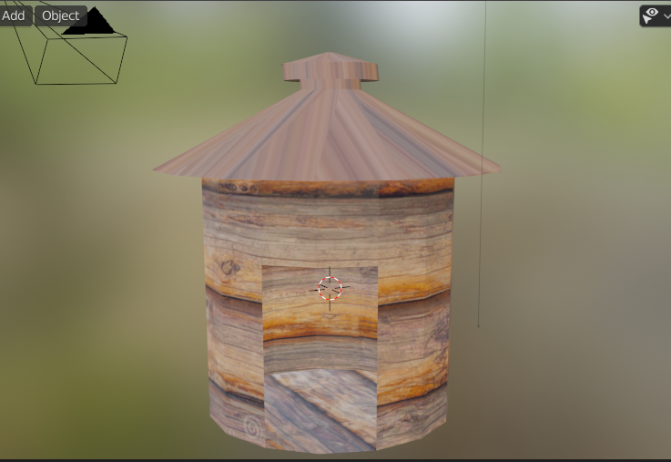

**LINK:**

https://drive.google.com/drive/folders/1MnmUDSb44Erm28BVcM0R37Bl7iqrpZ2v?usp=sharing